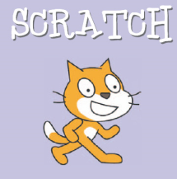**Scratch Disco**

**Objectives**

1. To understand what scratch is and how it works
2. To create an animation of a moving sprite
3. To create a background that changes

**Make a disco background**

**Step 1**: Create a background

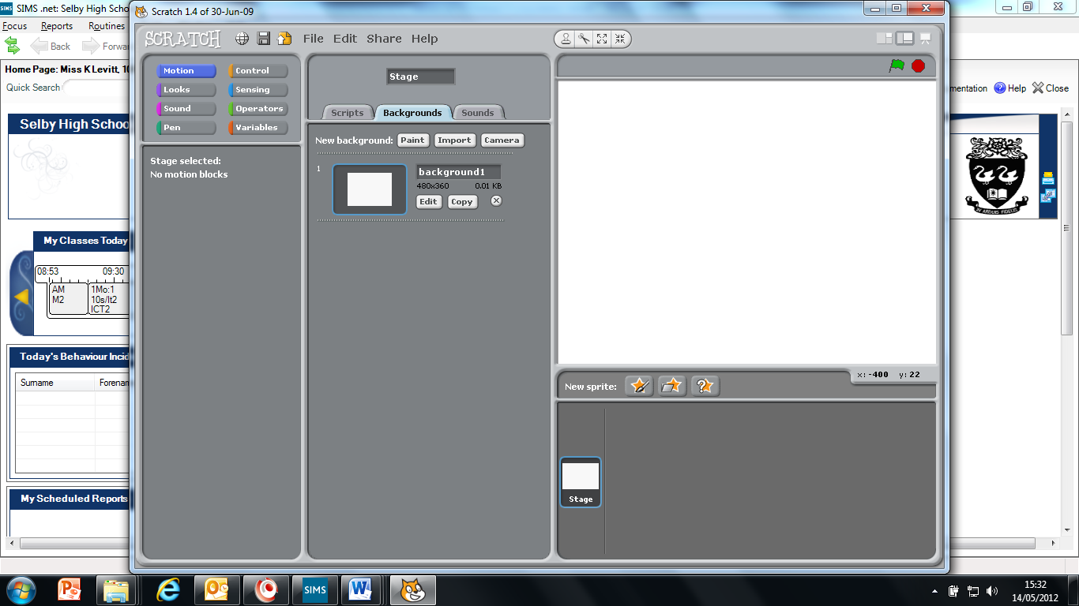

1. Select the stage
2. Select the background
3. Edit the background.

**Step 2:** Edit the background

Use the drawing tools to create a disco background.

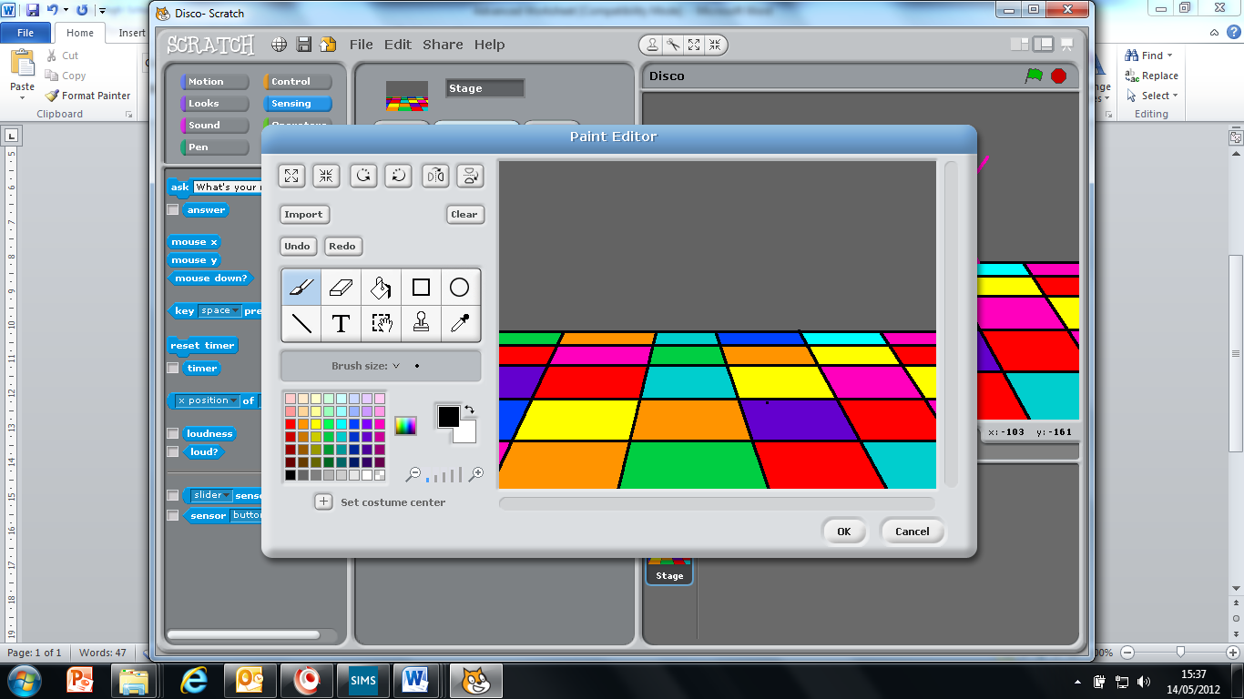

**Step 3:** Duplicate the background

1. Copy the stage to create at least 2 backgrounds.

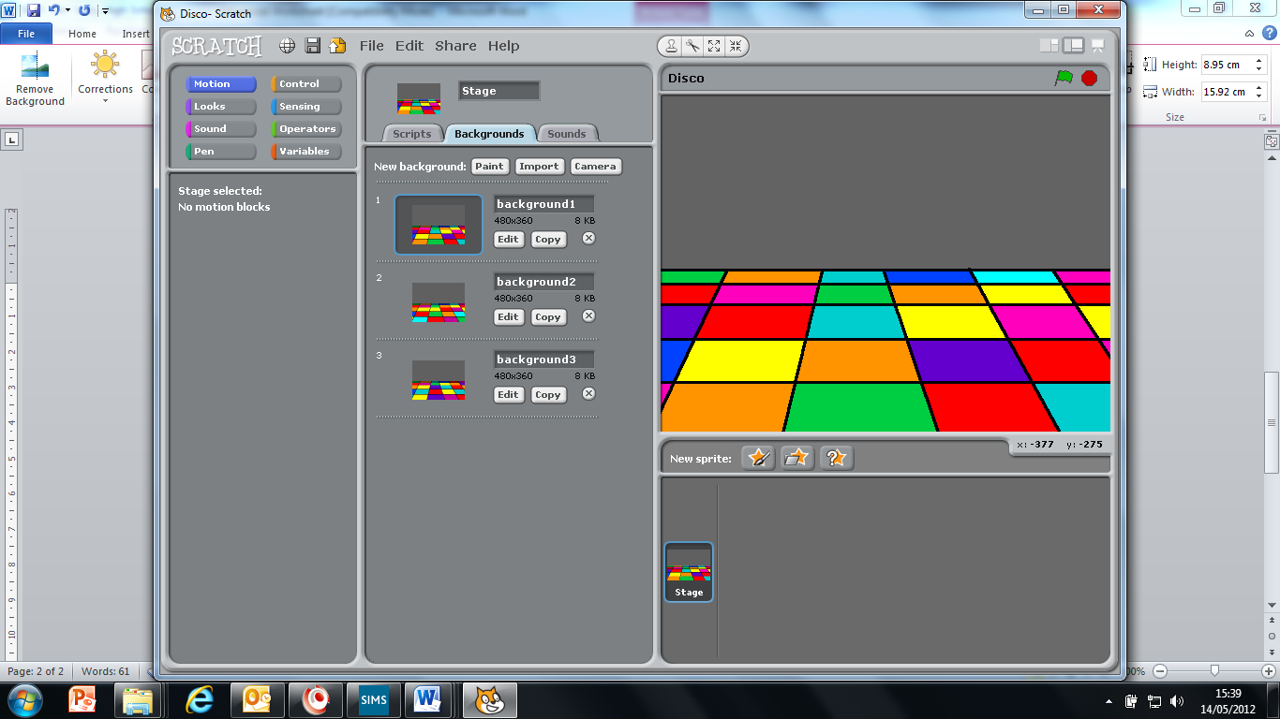

1. Edit the backgrounds so that each one is different.

**Step 4:** Make the background flash.

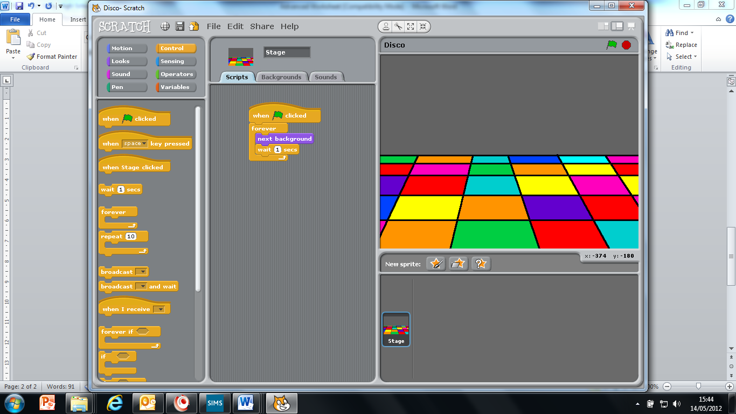On the **SCRIPTS** tab, enter the following code.

When the flag is clicked, it will switch to the next background, wait one second, then switch to the next background. This will loop forever.

**Test that it works by pressing the green flag** 

**Make a sprite from the library move**

**Step 5:** Get a sprite from the file

Find a new sprite from the library

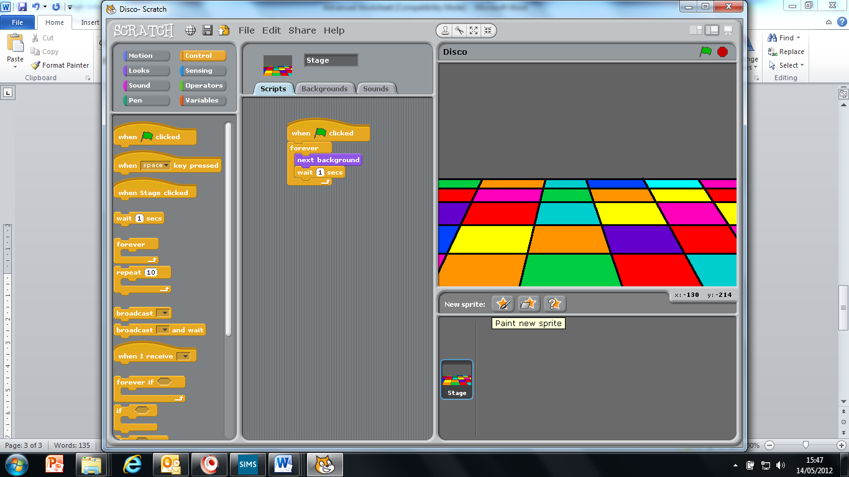

**Step 6:** Get the sprite dancing

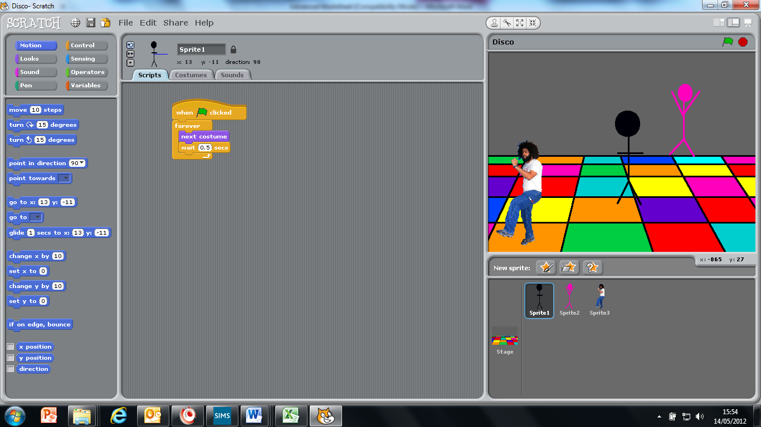Edit your script to make the sprite move with the blue motion commands.

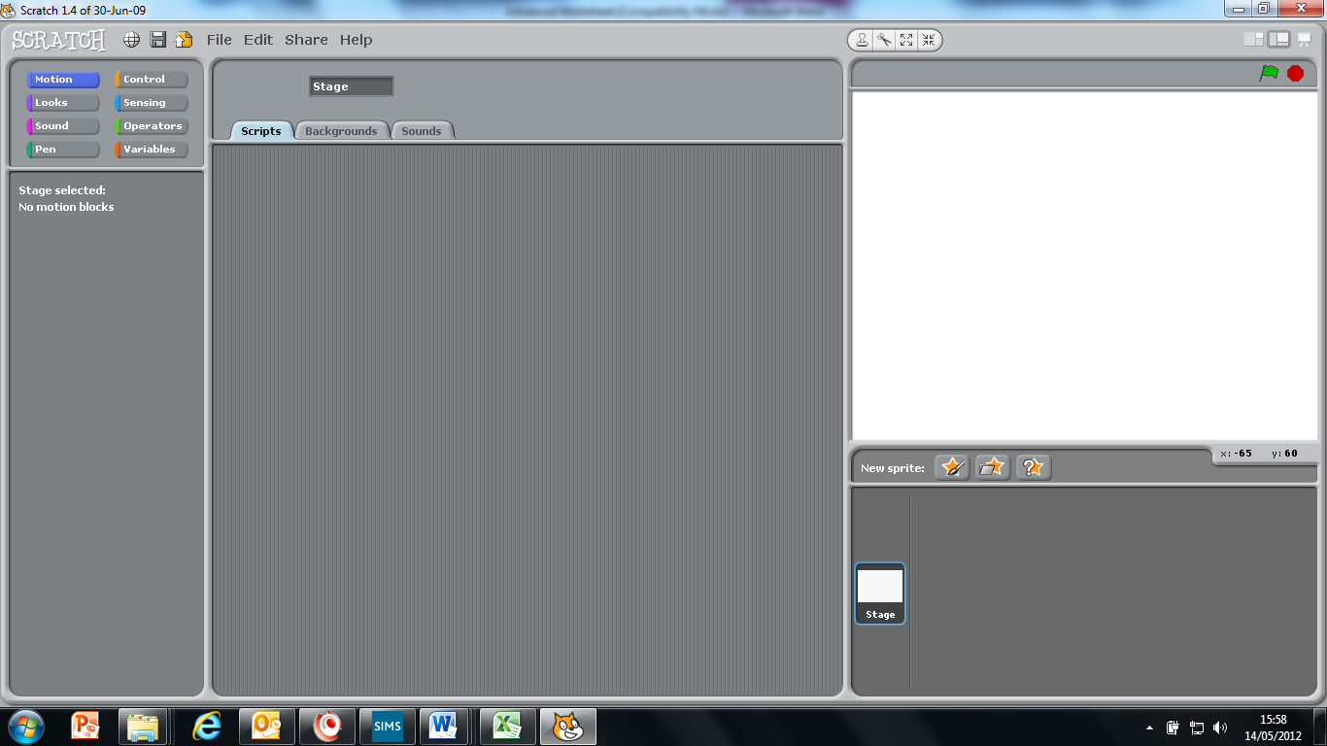

The stage is designed around co-ordinates to record the position of your sprites. *If you move your mouse you will see the co-ordinaries change as it records the position of your mouse*

**X**

**Y**

Make it glide to, or go to certain co-ordinates.

Make it point in a certain direction

Make it rotate on the spot

Make it move 10 steps

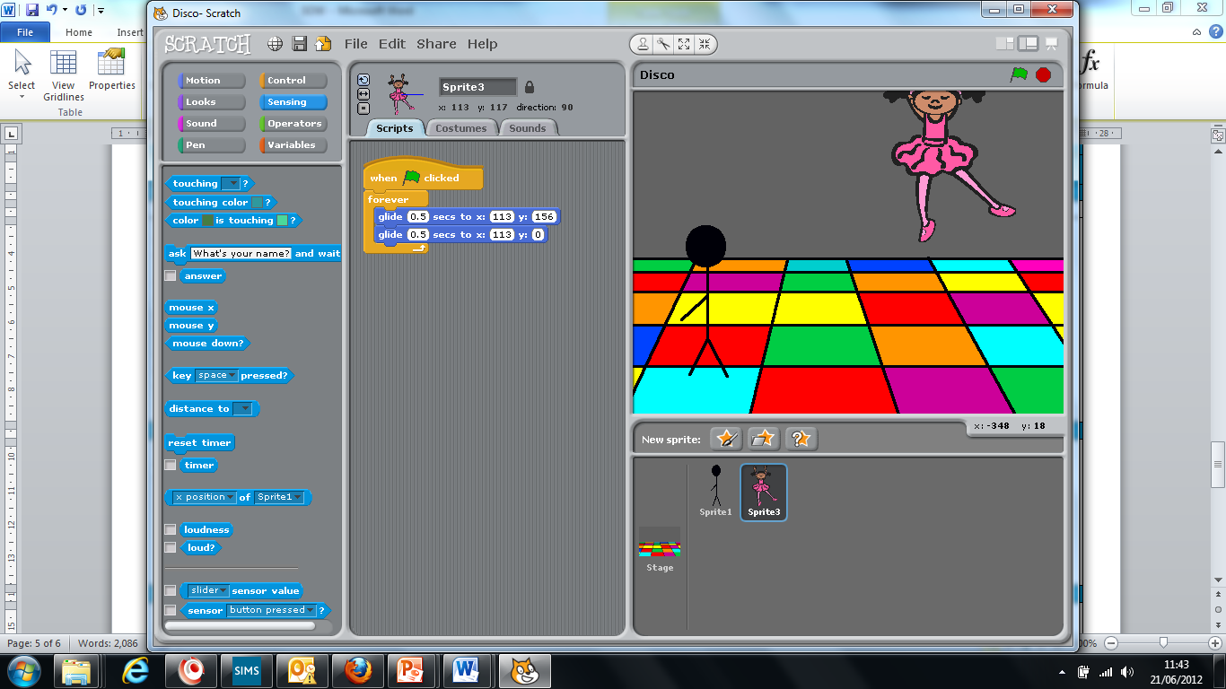

**Make a painted sprite change costumes**

1. Click Paint New Sprite. .

**Step 7:** Make a new sprite that you can program to dance.

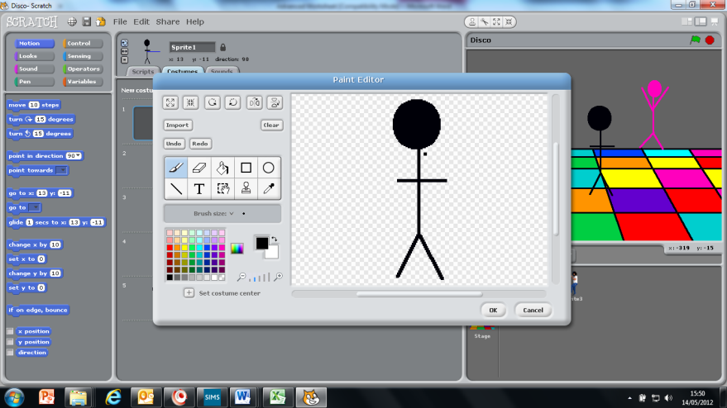

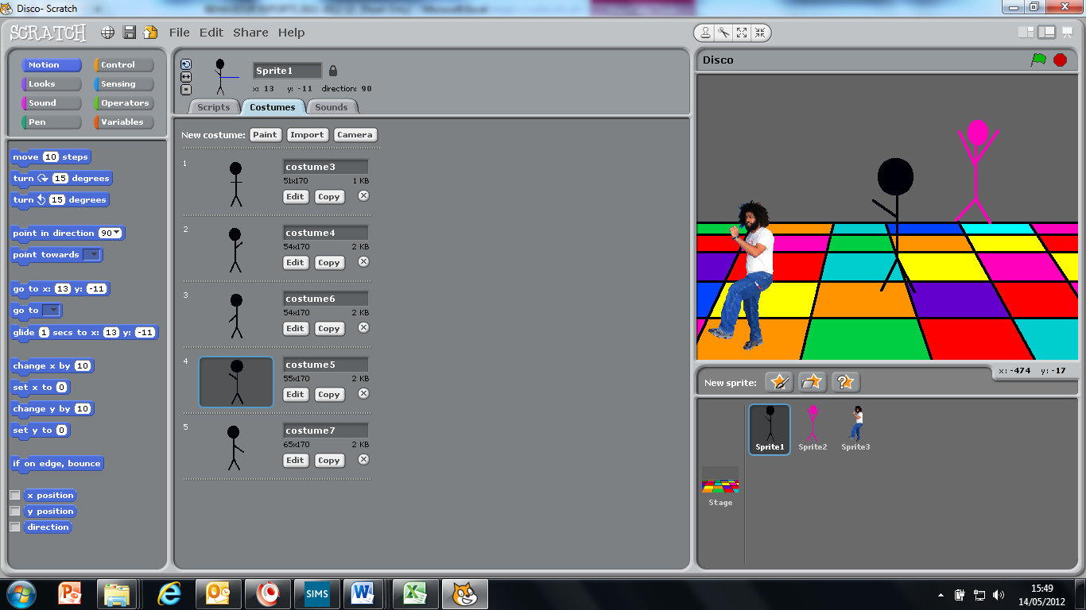**Step 8:** Duplicate the sprite’s costume

1. Click on the costumes tab .
2. Copy your sprite and edit each costume, like you did with the background

**Step 9:** Get the sprite dancing

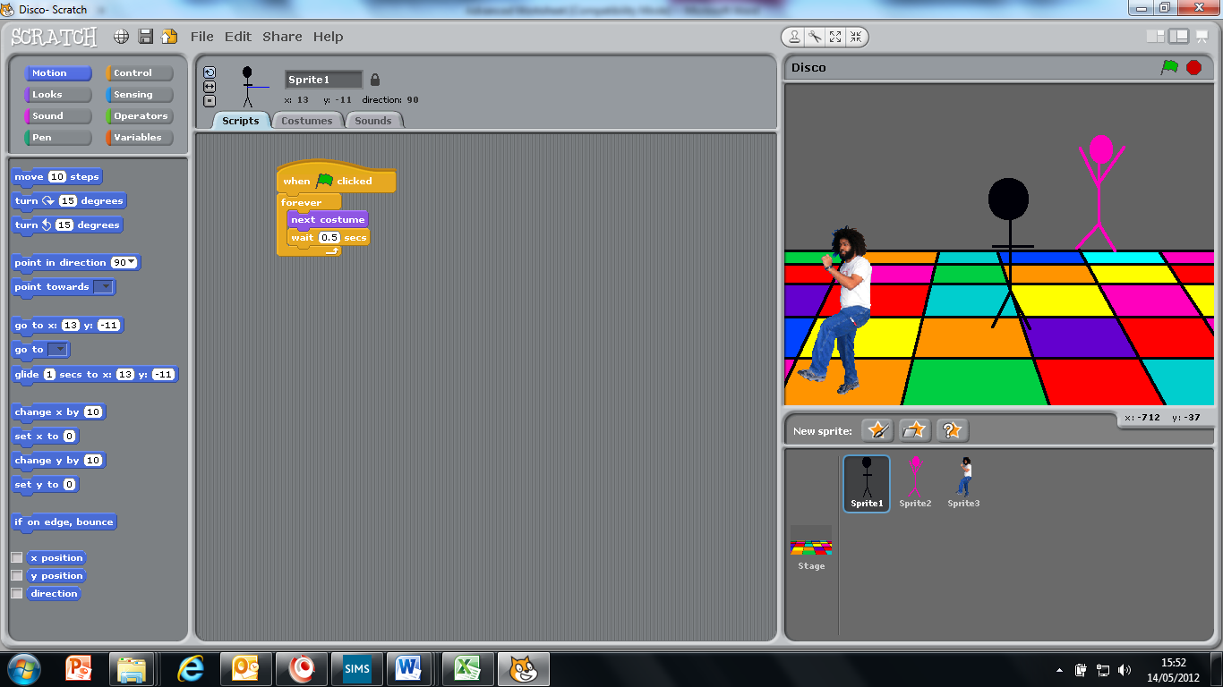On the Scripts tab, enter the following code.

When the flag is clicked, it will switch to the next costume, wait one second, then switch to the next costumes. This will loop forever.

**Test that it works by pressing the green flag**